✅ PRODUCT MANAGER / PRODUCT OWNER INTERVIEW REFERENCE NOTES
A structured, comprehensive guide to prepare for PM interviews, from product sense to strategy, metrics, technical, and behavioral rounds.
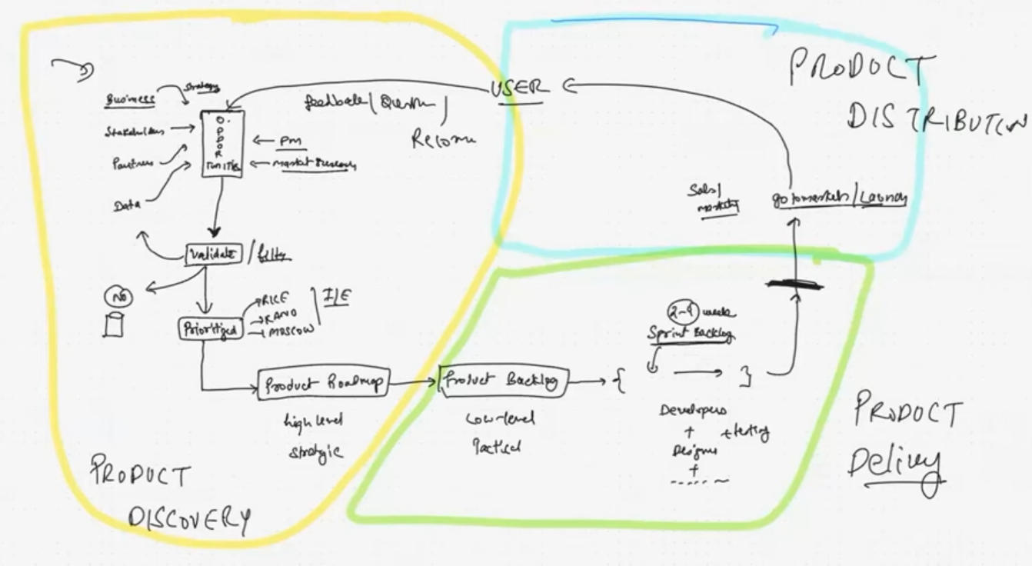
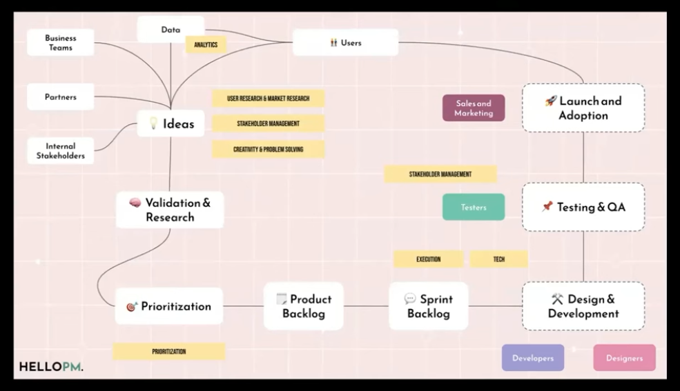

✅ AGENDA
- Resume Review + Profile Scan
- Video Retrospective
- Building UI/UX Capabilities
- Examples of Good / Bad / Ugly Product Scenarios
- PM Concept Recap

✅ PART 1 — UNDERSTANDING PM INTERVIEWS

✅ What is the PM Job?
Product Managers:
- Identify user problems and opportunities
- Guide the team to build valuable products
- Own outcomes, not just features
- Balance Business + User + Tech

✅ Core Skills
✅ Problem Solving
✅ User Empathy
✅ Communication
✅ Prioritization
✅ Data Literacy
✅ Market & Business Sense
✅ Product Execution

✅ PM INTERVIEW STRUCTURE
Typical process:
- Recruiter / HR Screening
- Hiring Manager Intro
- Take-Home Assignment (sometimes)
- Product Sense
- Metrics
- Root Cause / Problem Solving
- Strategy
- Behavioral
- Negotiation & Offer

✅ PART 2 — TYPES OF PM INTERVIEW QUESTIONS

✅ (A) PRODUCT SENSE
Assesses user empathy, creativity, structured thinking, and product intuition.
Example Questions
- How would you improve Google Maps?
- How would you design a refrigerator for visually impaired people?
- Build a parking-finding feature in Google Maps
- Improve LinkedIn for job seekers
- Build a learning product for YouTube
✅ Goal when answering:
Show strong understanding of:
- Users
- Problems
- Solutions
- Business Goals
- Tradeoffs

✅ Product Sense Answer Framework
1. Clarify the question
- Ask questions to remove ambiguity
- Confirm whether it’s for a specific region, user group, business objective
2. Define Goals
- Increase revenue? Users? Retention? Engagement?
3. Identify Users
Example (Google Maps parking feature):
- Daily commuters
- Tourists
- Delivery drivers
4. Identify User Problems/Needs
- Difficulty finding parking
- Parking cost variations
- Safety concerns
5. Prioritize problems
Pick top 2–3 that have highest value impact
6. Offer Solutions
Examples:
- Live parking availability
- Dynamic pricing visibility
- Parking alerts based on destination
7. Success Metrics
- Increase in saved navigation locations with parking
- Decrease in time users spend searching for parking
- User satisfaction ratings
8. Summarize clearly

✅ The Fundamental Law of Product Management
Businesses grow when they provide value.
Users repay through money or attention.
✔ PM must satisfy BOTH:
- The User
- The Business
Hence PM is called “The Voice of the Customer.”

✅ Recommended Structure (Very Important)
1 - Clarify the problem
2 - Define users & goals
3 - Identify user pain points
4 - Propose solutions/features
5 - Define success metrics
6 - Summarize

✅ PART 3 — METRICS QUESTIONS
Tests:
- Data thinking
- Measurement of success
- Business sense
Example Questions
- Define success for Spotify Podcasts
- Measure effectiveness of eBay search ranking
- Success metrics for DoorDash delivery
- Metrics to measure Instagram Reels performance

✅ Metrics Answer Framework
✅ STEP 1 — Clarify the scope
Example: “Success for whom? Creators, viewers, advertisers?”
✅ STEP 2 — Why does this product exist? Hypothesis
- Instagram Reels → retain younger audience + beat TikTok
✅ STEP 3 — Map the User Journey
Example for Reels:
- Opens app → scrolls feed → watches reels → likes/shares → follows → returns tomorrow
✅ STEP 4 — Build a Metric Tree
- Leading Metrics: immediate outcomes
- Lagging Metrics: long-term results
✅ STEP 5 — Guardrail Metrics
Ensure improvements don’t harm other areas.
FEATURE | SUCCESS METRIC | GUARDRAIL
Referral Program | # of invites sent | Cost per acquisition shouldn’t spike
SEO | # of downloads | App rating shouldn’t fall
Ratings & Reviews | NPS / trust score | Conversion must not drop

✅ Example of Leading vs Lagging
- More Active Users ⇒ more stories viewed (Leading)
- More Active Users ⇒ higher revenue after 6 months (Lagging)
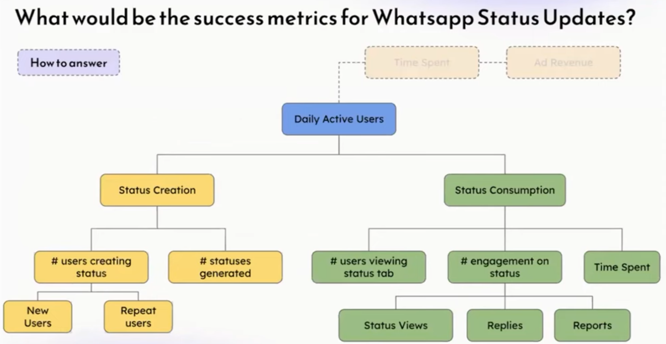

✅ PART 4 — ROOT CAUSE ANALYSIS
Used to assess structured thinking + analytical skills.
Example Questions
- FB Newsfeed engagement dropped, what do you do?
- Instagram impressions fell by 30%, what next?
Approach:
✔ Ask for data
✔ Analyze funnels
✔ Check releases/bugs
✔ Check competition
✔ Check seasonality
✔ Form hypotheses
✔ Create experiments
✔ Fix & measure again
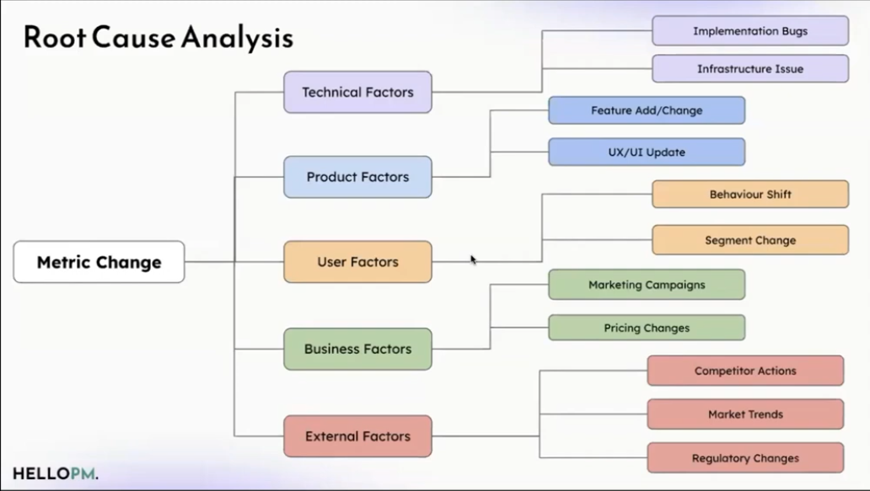

✅ PART 5 — STRATEGY QUESTIONS
Tests business sense, market understanding & long-term thinking
Example Questions
- Should Google enter Health & Fitness?
- How to increase profitability for BlinkIT?
- How should Netflix grow revenue?
- How to decide if we should acquire Company B?

✅ Strategy Framework
- Porter’s 5 Forces – Industry attractiveness
- 3C / 4P Framework – Customer, Company, Competition (Product/Place/Price/Promotion)
- Issue Trees – Break down problem into small parts
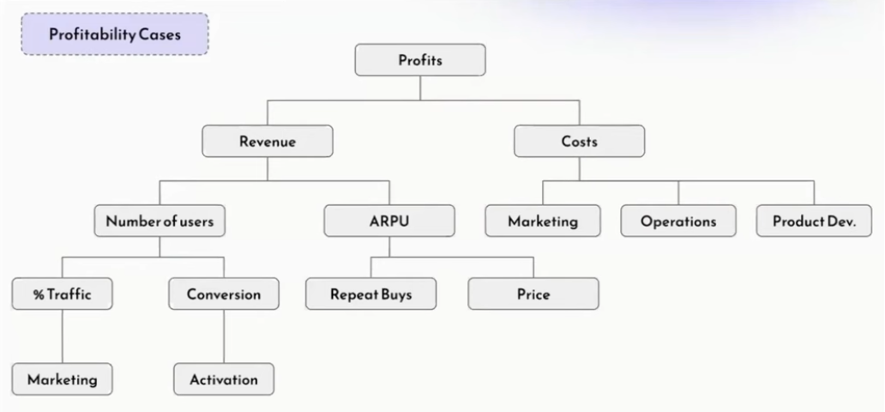

ARPU - Average Revenue Per User

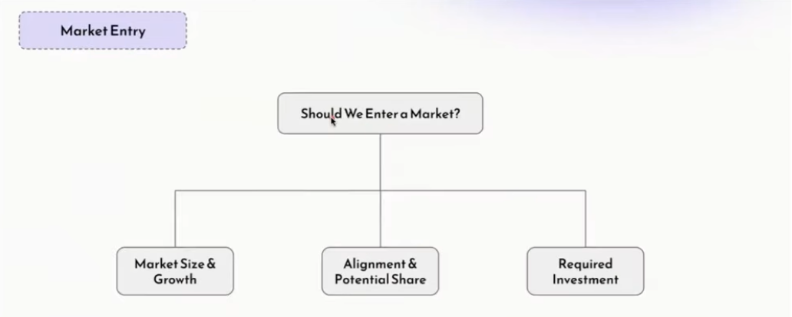

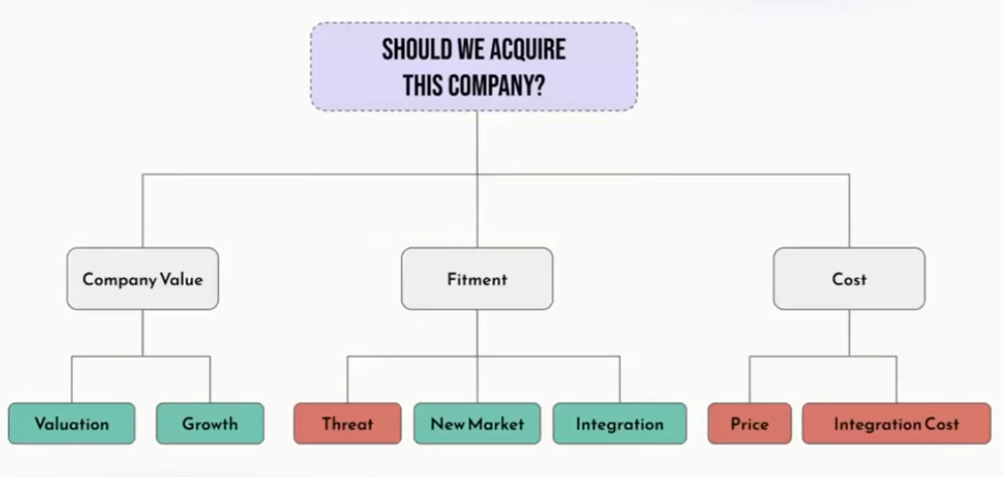

✅ PART 6 — BEHAVIORAL QUESTIONS
They check personality, attitude, culture fit & leadership.
Common Questions
- Tell me about yourself
- How did you handle a difficult stakeholder?
- A conflict you resolved?
- One weakness you improved?
- A big win you’re proud of?

✅ Behavioral Answer Format (STAR+LEARN)
✔ Situation
✔ Task
✔ Action
✔ Result
✔ Learning (very important!)
Tips
✅ Never bad-mouth anyone
✅ Give real examples, not theory
✅ Show impact with numbers
✅ Show that you do not repeat mistakes
✅ Highlight your direct contribution

✅ PART 7 — TECHNICAL QUESTIONS
Purpose: Not to code, but to show you understand how technology works.

Types of Technical PM Questions
✅ 1. Common Tech Terms
- What is an API?
- Why is cache fast?
- What is CDN?
- How does YouTube work end-to-end?
✅ 2. Experience-based
- What APIs have you worked with?
- What tech systems did you integrate with?
✅ 3. Stakeholder / Execution
- How do you get dev estimates?
- How do you prioritize bugs vs features?
- How do you manage tech debt?
✅ 4. Explain like I’m 5
- Explain database to a child
- Explain payment processing to your grandmother
(Use analogies)
✅ 5. Problem Solving
- Improve website speed
- Measure API performance
- Algorithm to estimate Swiggy delivery time

✅ HOW TO PRACTICE PRODUCT INTERVIEWS
✔ Review frameworks
✔ Practice with real questions (Glassdoor, Blind, Lewis Lin)
✔ Record yourself answering
✔ Use AI to critique
✔ Get a practice buddy

✅ KEY TO BECOMING A STRONG PM
Information → Knowledge → Skill
Skill only develops through Practice + Reflection

✅ 15 WEEK LEARNING PLAN (Suggested)
- User & Market Research
- Product Growth
- Product Ops
- Product Analytics
- Technology for PMs
- Product Thinking
- AI for PMs
- UX & Design
Tools: Figma, Mixpanel, Metabase, GA, Jira, Asana
